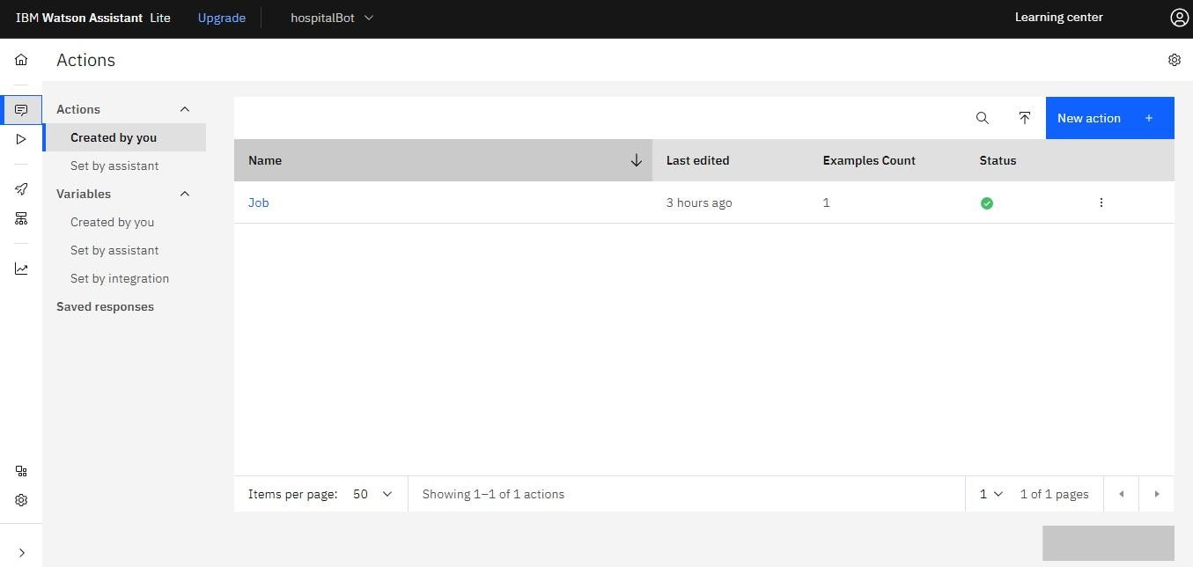

DEVELOPING THE CHATBOT

|  |  |
| --- | --- |
| Date | 10 NOV 2022 |
| Team ID | PNT2022TMID05015 |
| Project Name | Skill and Job Recommender Application |

